FPR Report(draft): Smart Baby Crib
Xinwen Zou, EE, Danshu Shen, EE, Jisen Hu, EE, and Mingkai Xiang, EE
Abstract—With the development of science and technology, people's life is gradually improved, many families with infants and young children want their children to have a better growth environment. Now, what parents need is not only a cozy cradle but also a helper who can monitor baby and alert them in real-time. Therefore, we decided to design a smart crib to meet this need. Although there are several similar products on the market, they vary in functionality and are very expensive. Through the combination of sensors and cloud, our product allows users to remotely check the health data of their babies on their mobile phones and warn them of abnormal conditions.

INTRODUCTION
O
ur product is designed to be convenient for babies and their guardians. we want to develop a crib with automatic sleep coaxing function that allows guardians to check their baby's health anytime and anywhere. This entails: Detect baby’s temperature, sound, and heartbeat using a temperature sensor, acoustic sensor, and a heartbeat sensor hiding in a sock. Real-time monitoring using an application with Wi-Fi connection. simulate parents’ movement to comfort baby by activating a swing motor when the acoustic sensor detects and recognizes baby crying.

Significance
Babies grow up in sleep, so a good sleep is crucial to their healthy growth, and parents are racking their minds to guarantee that. To provide a comfortable sleeping environment for the baby, we need to configure a smart baby crib that can bring scientific health protection to parenting, help parents better care for the baby, very conducive to the baby's sleep. For example, when a baby feels too cold or too hot, they will be fidgety and crying non-stop. With the help of Smart Baby Crib, the "temperature detection" function allows parents to master the changes of infant temperature in real time and record the health data of the baby. Reduce environmental influence on infant sleep.

Context and Competing Solutions in Marketplace
There are two exiting solutions we found:
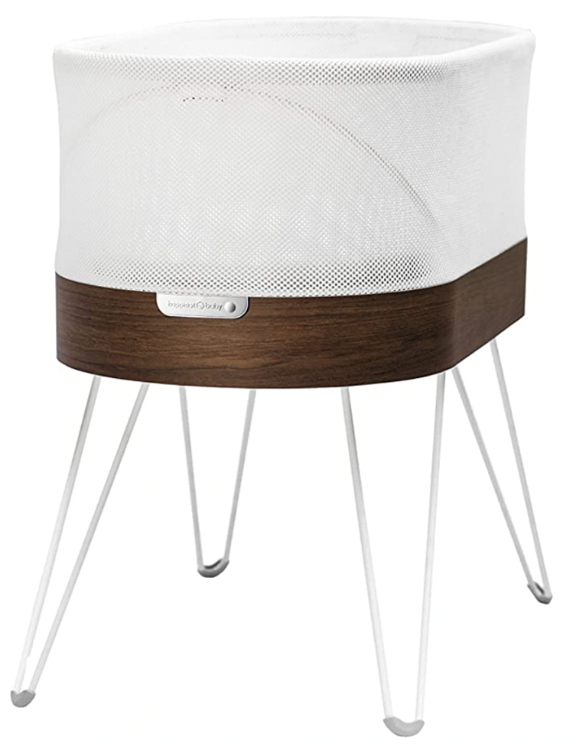
- SNOO Smart Sleeper：came out in 2016 with automatic Rocking Motions and Smoothing White Noise. However, this product does not have a temperature detector. Using white noise to calm down baby, parents will not know exactly why baby is crying. (such as: change in heart rate)
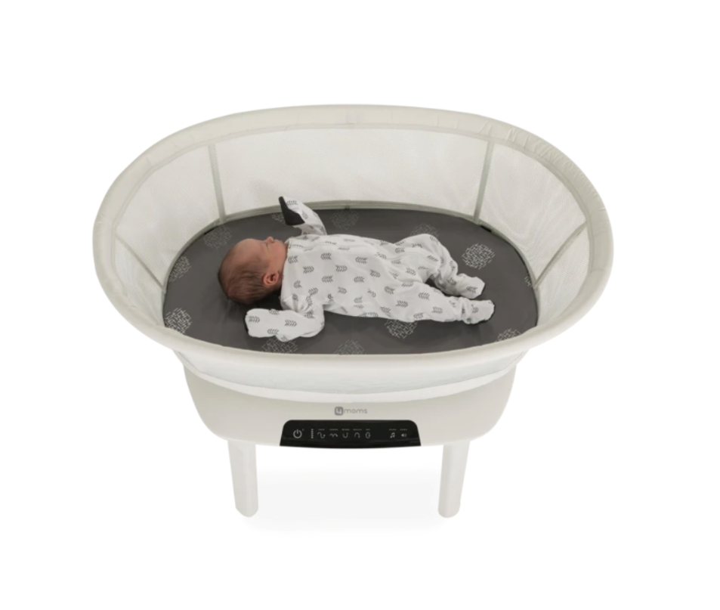
- mamaRoo sleep bassinet：came out in early 2020. This product cannot detect baby breathing. Parents have to constantly check baby's temperature
Fig. 2. mamaRoo sleep bassinet respiration while they are sleeping.

Our solution is the Smart Baby Crib. Our smart baby crib can detect baby’s temperature and heartbeat using a temperature sensor and a heartbeat sensor hiding in a sock. It is implemented a respiratory acoustic sensor to detect baby’s breathing during sleep. It also simulates parents’ movement to comfort baby by activating a swing motor when the acoustic sensor detects and recognizes baby crying.

Societal Impacts
A smart crib at home was associated with reduced infant crying and increased infant and maternal sleep. Such a smart crib might be a responsive intervention for excessively crying infants, and exhausted mothers who feel in need of help with soothing infant crying and for help with boosting infant sleep. As such it may help break the vicious cycle between infant crying and parental exhaustion.

System Requirements and Specifications
1. System shall detect a baby’s temperature 30 – 41 Celsius (86-105 Fahrenheit), heartbeat (110-160 beats per minute.), and all the sensors could work 24/7 with a power charger.

2. System shall transmit the data to an application through the WIFI module, allowing parents to monitor the data simultaneously.

3. System shall upload the collecting data into an online server once per 300ms.

4. System shall detect and recognize the baby crying using a sound sensor by its noise level; over 90 dB.

5. The noise of swing motor is lower than 40 dB and swing angle is less and equal to 15 degrees.

Design

Overview
How did you solve this problem? Describe design alternatives that you considered before settling on your design. Refer to the Appendix (Section A) for more details as needed. What technologies did you use and what technical standards did they satisfy Appendix (Section B). Why did you expect that this technology will solve your problem? What other technologies did you consider? Describe how satisfaction of multiple specifications listed in Table 1 imposed tradeoffs on your overall design.
Include the system block diagram and software diagrams as figures and refer to them in the text as in “See the block diagram in Figure 1.” Do this for all figures used in the report. Describe each block (and each signal path) in the diagram. What (sub-system level) specifications do each block meet? How do these sub-system specifications collectively guarantee that the system meets its overall specifications?

We are using multi-sensors hidden in a sock, keep collecting data from baby. See the block diagram in Figure 1, the temperature sensor and pulse sensor are embedded in a sock, and acoustic sensor in inside the crib. All of them are connected to the microcontroller, microcontroller will control the motor with a motor drive. The collecting data is transmitted through a WIFI module to an application interface. User could remotely check the data from their phone or iPad in real time.

Block 1
Describe what this technical block does. Explain what technology you used to build this block. Include citations to data sheets for primary components as in “To detect motion, we used the passive infrared sensor (PIR) module SE-10 [2].” Detail which techniques from courses you used to build this block. List what you learned in order to build this block. Summarize an experiment you performed to design or test this block. Refer to Appendix (Section C) for more information about the experiment as needed.

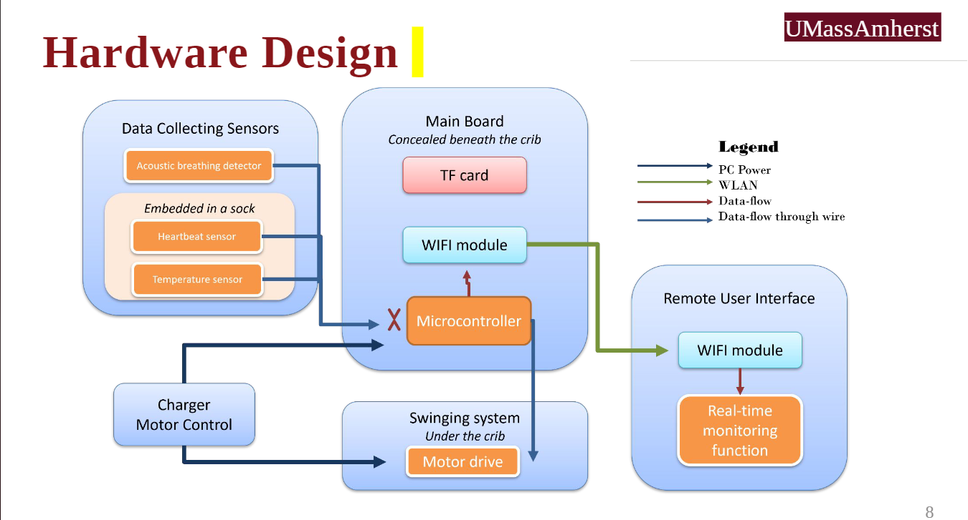
Fig. 3. Hardware design of our system.

Block 2
Describe what this technical block does. Explain what technology you used to build this block. Detail which techniques from courses you used to build this block. List what you learned in order to build this block. Summarize an experiment you performed to design or test this block. Refer to Appendix (Section C) for more information about the experiment as needed.
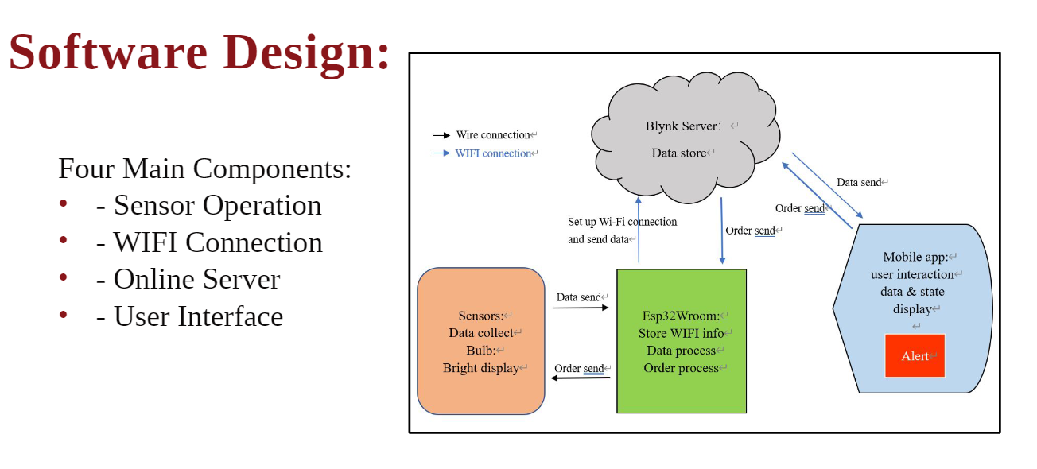
Fig. 4. Software design of our system.

Block 3
Describe what this technical block does. Explain what technology you used to build this block. Detail which techniques from courses you used to build this block. List what you learned in order to build this block. Summarize an experiment you performed to design or test this block. Refer to Appendix (Section C) for more information about the experiment as needed.

Block 4
Describe what this technical block does. Explain what technology you used to build this block. Detail which techniques from courses you used to build this block. List what you learned in order to build this block. Summarize an experiment you performed to design or test this block. Refer to Appendix (Section C) for more information about the experiment as needed.

The Refined Prototype

A. Prototype Overview
Our refined prototype consists of any component from the original design as well as a finished crib. The Remote GUI consists of basic and complex interactive modes, including crib gear control, switches, mode selection, and display of baby status data. Allows basic operations and preset changes over Wi-Fi. The motherboard, now a fully assembled PCBA (Printed Circuit Board Assembly), receives input from various sensors and sets up presets/configurations to send data to an SD card, which is then sent over a Wi-Fi connection to the blynk cloud, where it is then sent to the user's phone. The motherboard receives instructions from the cloud to control and run the physical motor to achieve swaying.
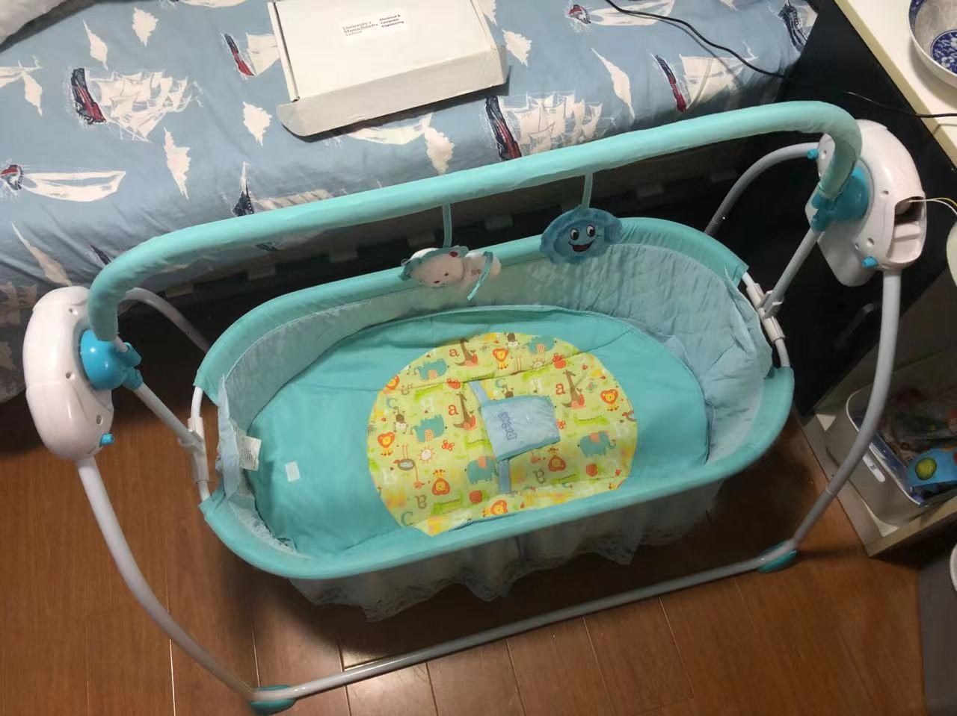
Fig. 5. Physical prototype of our smart baby crib
Hardware design of our system.

B. List of Hardware and Software
On the hardware side, our prototype uses many components. As mentioned earlier, the motherboard communicates with the GUI and sub board, which utilizes the ESP32 development board. The ESP32 is based on the ESP32-D0WD dual-core chip and is suitable for Wi-Fi and Bluetooth connection applications. Equipped with xTENSA 32-bit LX7 single-core processor, working frequency up to 240MHz. We use a double relay on the motherboard to realize the clockwise and counter-clockwise bidirectional control of the cradle motor. The use of LMV324 to achieve three level amplification of the sound circuit processing sound sensor, the main components and circuits are designed on the motherboard, separate external access to the microphone. The TMP117MAIDRVR from Texas Instruments is equipped with an external temperature sensor board to measure body temperature, as well as an external heartbeat sensor that cannot be configured because customized grating chips cannot be purchased.
On the software side, due to the special nature of ESP32, we mainly used Python programming in this project. Each peripheral required on the motherboard needs to have a clock routed to it and its register Settings configured to the desired functional mode. BlynkLib library is used for Wi-Fi communication, ESP-IDF library/environment is used for SPI communication and multithreading. The library of temperature sensor and SD card is written according to the function needs. Finally, our remote GUI was designed using the Blynk platform, using BlynkProtocol to build the interface, Process to serialize messages to communicate with the motherboard, and connect to the MQTT server to publish messages and subscribe to topics.

C. Custom Hardware
The most important custom hardware component designed in this project was the motherboard. Specifically, the design thought is to fix the PCB on the side of the crib, so, the external sensors that connected to the PCB motherboard can be connected with lines and placed close to baby to process signal sampling, so we can infer from the heart, temperature, noise and other data extracted from signals, processing and analysis them then sent to client.
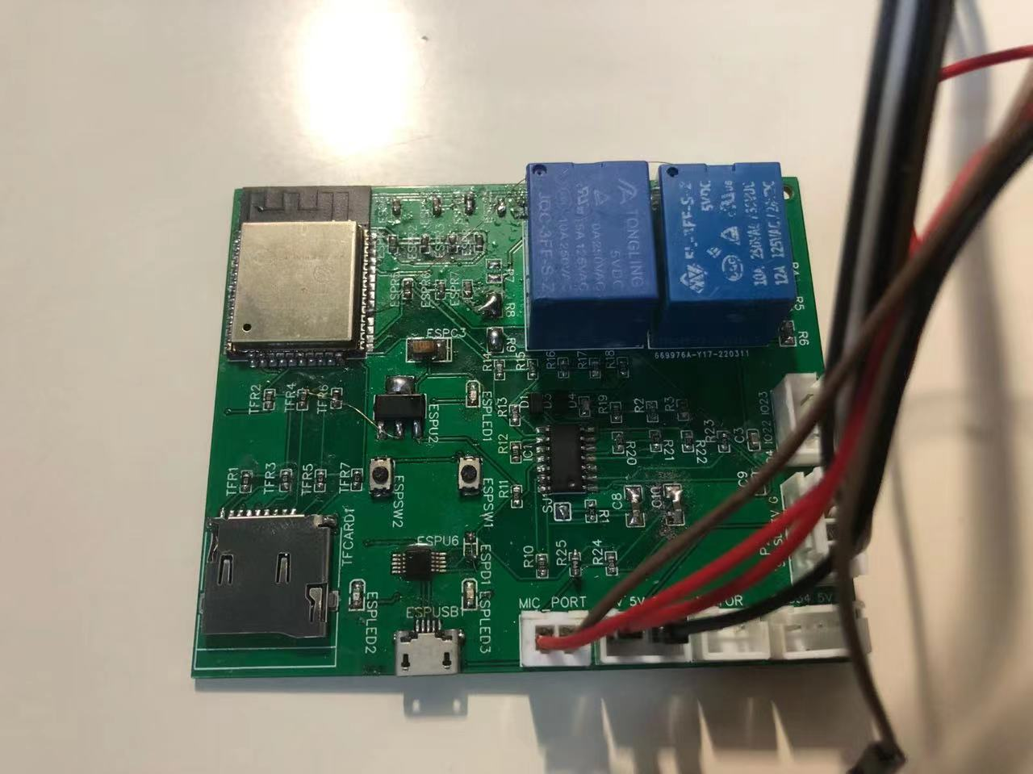
Fig. 6. A completed PCBA of the main board circuit
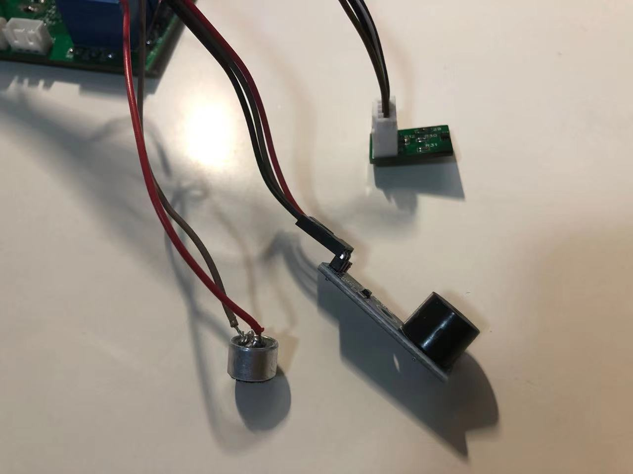
Fig. 7. External sensors

D. Prototype Functionality
Our working prototype has reached a semi-complete level of functionality. We are able to establish an end-to-end chain of interaction of the entire system: Starting from the UI, we are able to send a signal that travels over WIFI to the ESP32, which then relays that signal over SPI to the Motor, So the physical crib can be swayed at different levels on command. And the status of crib and baby's physical data can be feedback to the user in real time.

E. Prototype Performance
After testing, we discovered that on average, the Crib are able to react to the order within 1 seconds, which means the delay is ideal. After 10+ sway tests, and taking the averages of these values, we found that our system is capable of reaching a maximum shaking range at 30 degrees, which is large enough and pretty safe to babies. This is lower than we originally planned(design specifications called for 45 degree), but acceptable for safety reasons.

Conclusion
In summary, we are thankful that we have this opportunity to work on and design something by learning the knowledge over the past four years, by now we are proud to say that we have accomplished the milestones and goals of our SDP as members of Class 2022. In the last semester, we were mainly focusing on our mobile app control and monitor software by using phones or tablets via the Wifi module. We also set up the measurement for temperature, sound, and heartbeats sensors. The data was successfully stored over the cloud.
For CDR, we focused on making the heartbeats data more accurate than our previous vision. On the software development side, we tested the data storage and run a few tests, finally, we solved this issue by dropping the total beats to 60. On the hardware side, we had our first version of the swing system by pressing the button. By FPR, we have our system integrated with the PCB broad and the fully functional baby's crib. We are meeting all specs and our final goals, which marks a rather successful end to our SDP project.

Acknowledgment

We would like to acknowledge and thank our advisor, Professor Ramakrishna Janaswamy, for his generous patience, advice, and support throughout our SDP design project. We would like to acknowledge and thank our evaluators, Professor Bill Leonard and Beatriz Lorenzo for their informational feedback. We would also like to extend our thanks to Professor C.V. Hollot; Baird Soules; Shira Epsteina for suggesting and helping us figure out the best choices for our senior design project ideas and advising us, keeping us on track during check-in dates. Also, we would like to thank Wouter Schievink for helping us place orders of components that we need for the SDP project throughout the year. Finally, we would like to acknowledge and thank UMass Amherst for providing this special opportunity to explore the adventure in our life.References

- V. Smil, “Energy-Conversion Efficiency is Falling,” IEEE Spectrum, pg. 18, February, 2021.
- PIR Sensor Module, SE10, Data Sheet, Sparkfun, https://www.sparkfun.com/datasheets/Sensors/Proximity/SE-10.pdf .
- G. O. Young, “Synthetic structure of industrial plastics (Book style with paper title and editor),” in Plastics, 2nd ed. vol. 3, J. Peters, Ed. New York: McGraw-Hill, 1964, pp. 15–64.
- W.-K. Chen, Linear Networks and Systems (Book style). Belmont, CA: Wadsworth, 1993, pp. 123–135.
- H. Poor, An Introduction to Signal Detection and Estimation. New York: Springer-Verlag, 1985, ch. 4.
- B. Smith, “An approach to graphs of linear forms (Unpublished work style),” unpublished.
- E. H. Miller, “A note on reflector arrays (Periodical style—Accepted for publication),” IEEE Trans. Antennas Propagat., to be published.
- J. Wang, “Fundamentals of erbium-doped fiber amplifiers arrays (Periodical style—Submitted for publication),” IEEE J. Quantum Electron., submitted for publication.
- C. J. Kaufman, Rocky Mountain Research Lab., Boulder, CO, private communication, May 1995.
- Y. Yorozu, M. Hirano, K. Oka, and Y. Tagawa, “Electron spectroscopy studies on magneto-optical media and plastic substrate interfaces (Translation Journals style),” IEEE Transl. J. Magn.Jpn., vol. 2, Aug. 1987, pp. 740–741 [Dig. 9th Annu. Conf. Magnetics Japan, 1982, p. 301].

Appendix
Sections A - F are required appendix sections. You may refer to these materials in the report body as needed. An appendix is a useful catchall when there is too much detail to include in the report body, but where this content is still useful to be communicated. Include such details in Section G, H, … and so on.

Design Alternatives
In our original planned design, we had included an SD card on the PCB for data transmission and storage. However, it would require an SD reader library to support the formatting and there is no well-documented library for us to implement. And that will take us an entire effort to build this library from scratch as well as the PCB broad would exceed its dimension spec if we included an SD card slot. Therefore, we decided to abandon the SD card and store data inside the cloud over the microcontroller instead.

Technical Standards

During our project, we successfully implemented the collaboration between software and hardware for the entire technical reliability. In our project, we have adopted IEEE 255 and 260 Standard Letter Symbols for Semiconductor Devices, Standard Letter Symbols for Units of Measurement, for example, the temperature degree is represented by Celsius and Fahrenheit in our mobile app control; and noise level is represented by dB; the heartbeat is represented by beats per second. Also, we used a sound detector that meets the IEEE standard adheres to is IEEE 802.9 - Standards for integrated services, because we can detect the sound level to recognize whether the baby is crying or not. On the software side, we used Wifi. The IEEE standard it adheres to is IEEE IEEE 802.11 which is a part of the IEEE 802 standard for the wireless network. That will allow us to monitor the baby’s condition anywhere with the Wifi connection.

Testing Methods
In this appendix, we had done two major tests for our project. The first is the accuracy of our heartbeat measurement; the second test is for our swing system. For Test 1: xxxxxxx. For Test 2: And making sure when one is high at 5v, the motor should be able to turn on, and the other one is low at 0 V. So after the first step, the swing system testing was a little difficult, we set a timer at 200ms, it was too short because it can not reach the angle degree that we wanted, so we changed it to 300ms, the angle works ok but not smooth. so we finally set it at 280ms. The first level is at 280ms, the second level at 560ms, and the third is at 840ms. And this will keep the crib approximately at 30 degrees which meets our test plan.

Project Expenditures

Project Management
Describe how your team is organized. Describe how well or poorly the team is working. What is the expertise of each team member? How have you been helping each other out? How is your team communicating with each other? If possible and appropriate… Give an example of when each member provided leadership. Give an example of when each member helped another member. Give an example of when communication within the team broke down and what you did about it.

Beyond the Classroom
Each member should describe the skills they have needed to develop and the knowledge they have needed to learn as a result of this project so far. What resources have been useful to you? Do you see any connections between this and your life as a professional?

Additional Appendix Section

Additional Appendix Section

Fig. 1. SNOO Smart Sleeper F. A. Author from Lexington, Ma (e-mail: author@ boulder.nist.gov). S. B. Author, Jr., from Auburn, Ma (e-mail: author@lamar.colostate.edu). T. C. Author from Quincy, Ma (e-mail: author@nrim.go.jp).

